***Python Experiments with Codes and Outputs (7 Experiments):***

1. Write a program to Create, Insert and Display (Fetchall method) Students Record using Interfacing Concepts.

**Source Code:**

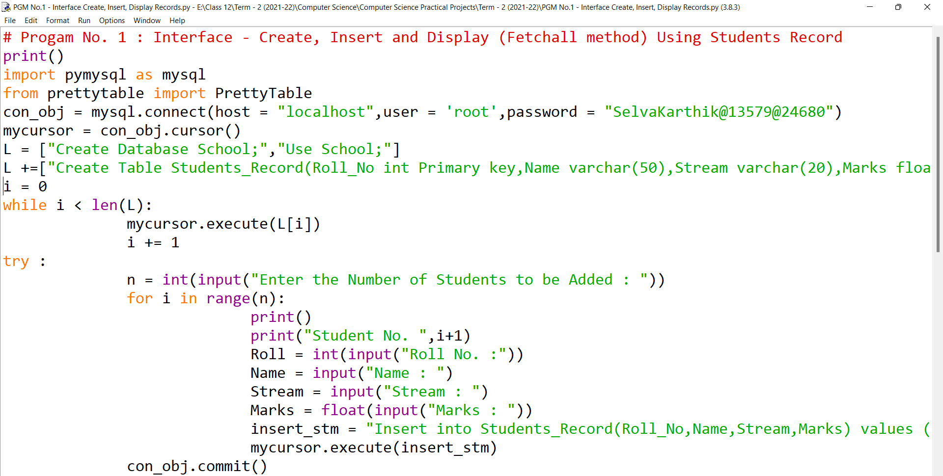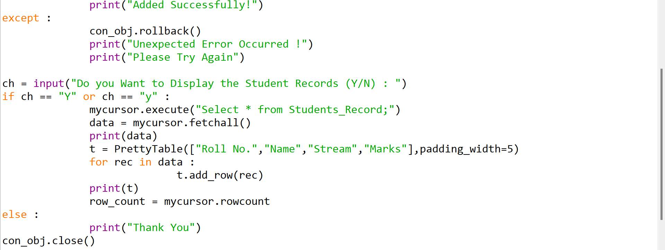

**Input/Output:**

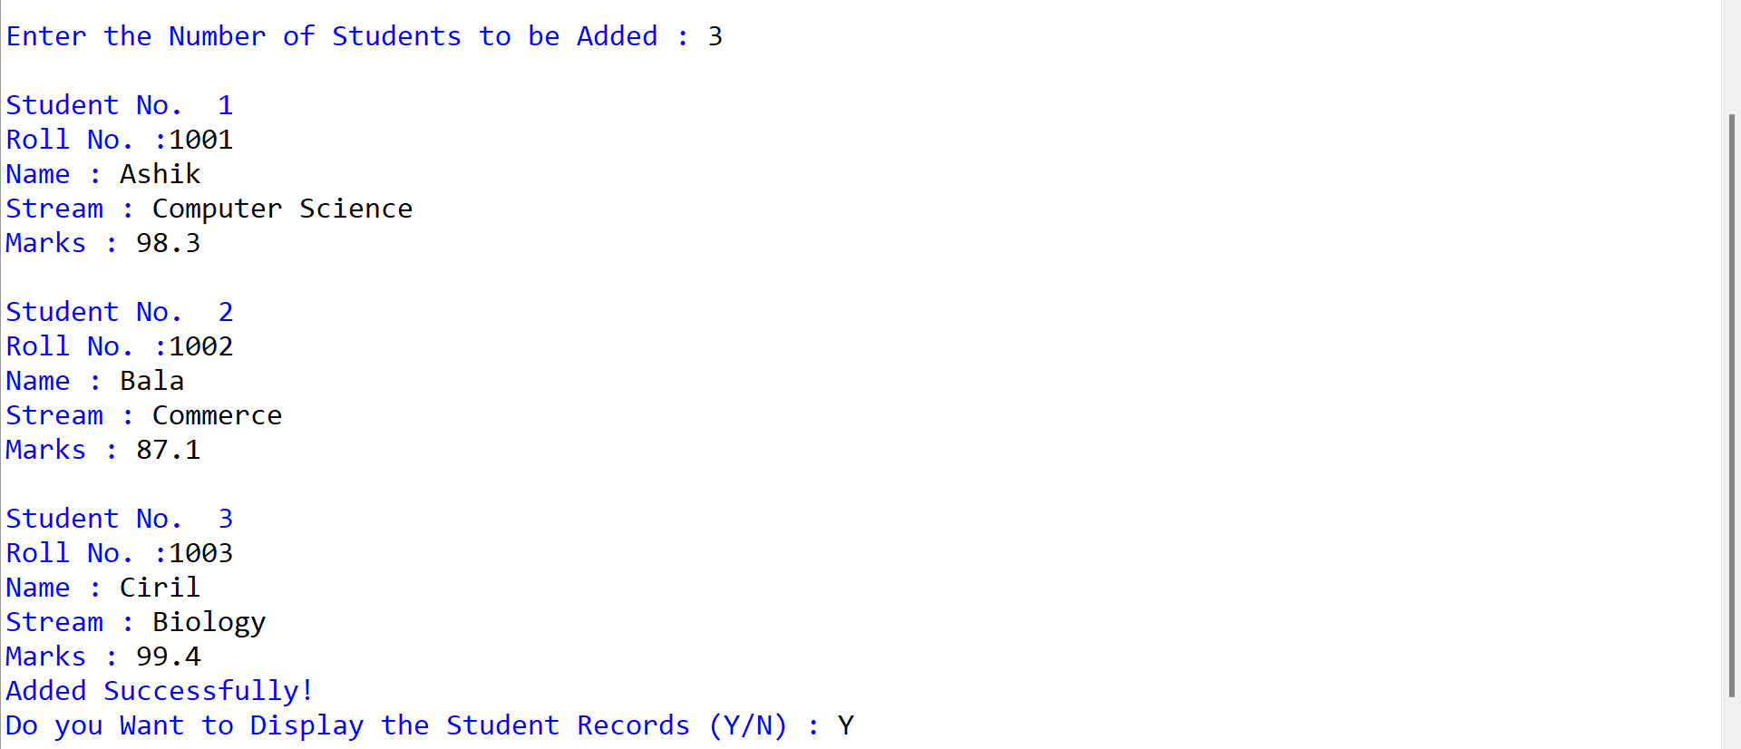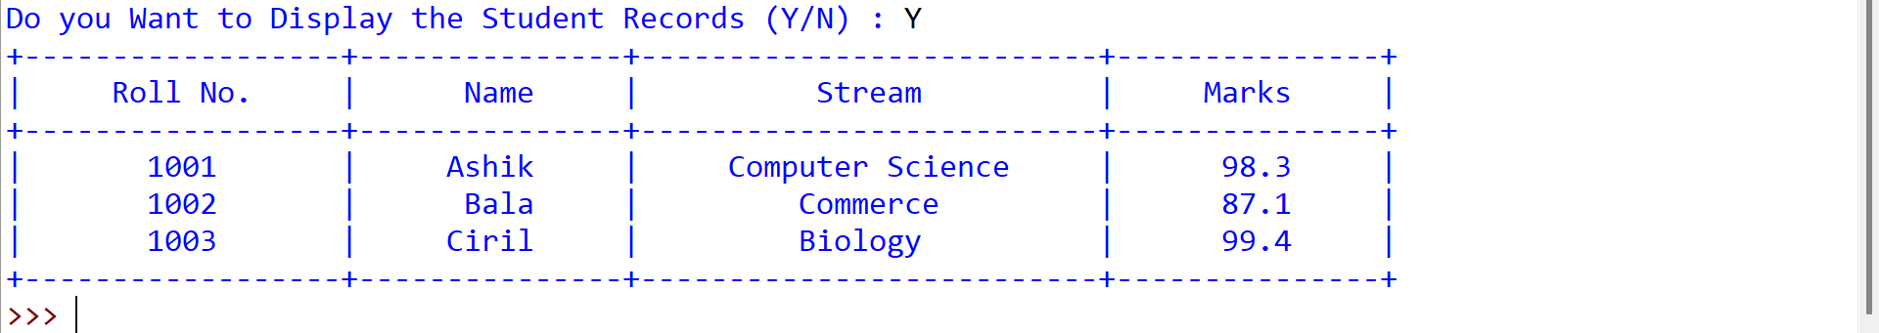

1. Write a program to Create, Insert,Update and Display (Fetchall method\Fetchmany method) Students Record Using Interfacing Concepts.

**Source Code:**

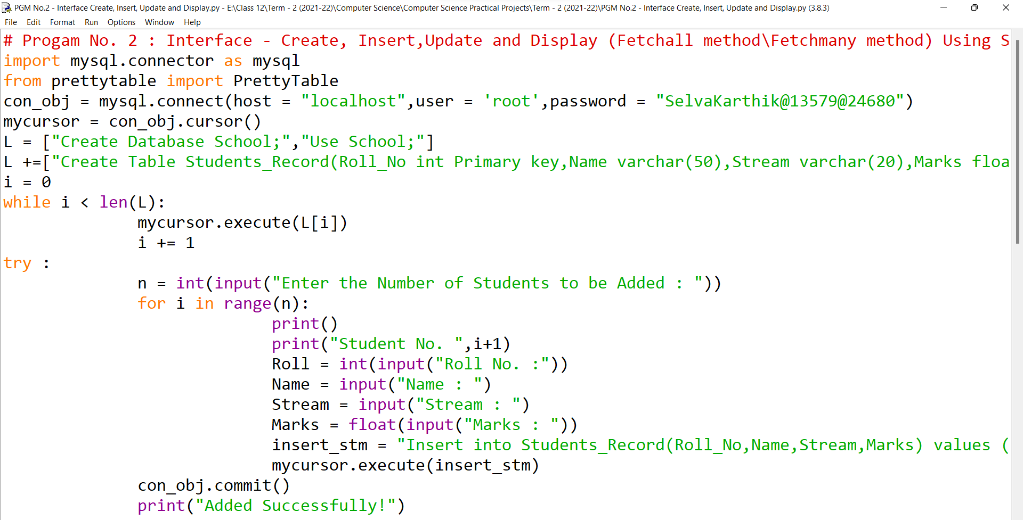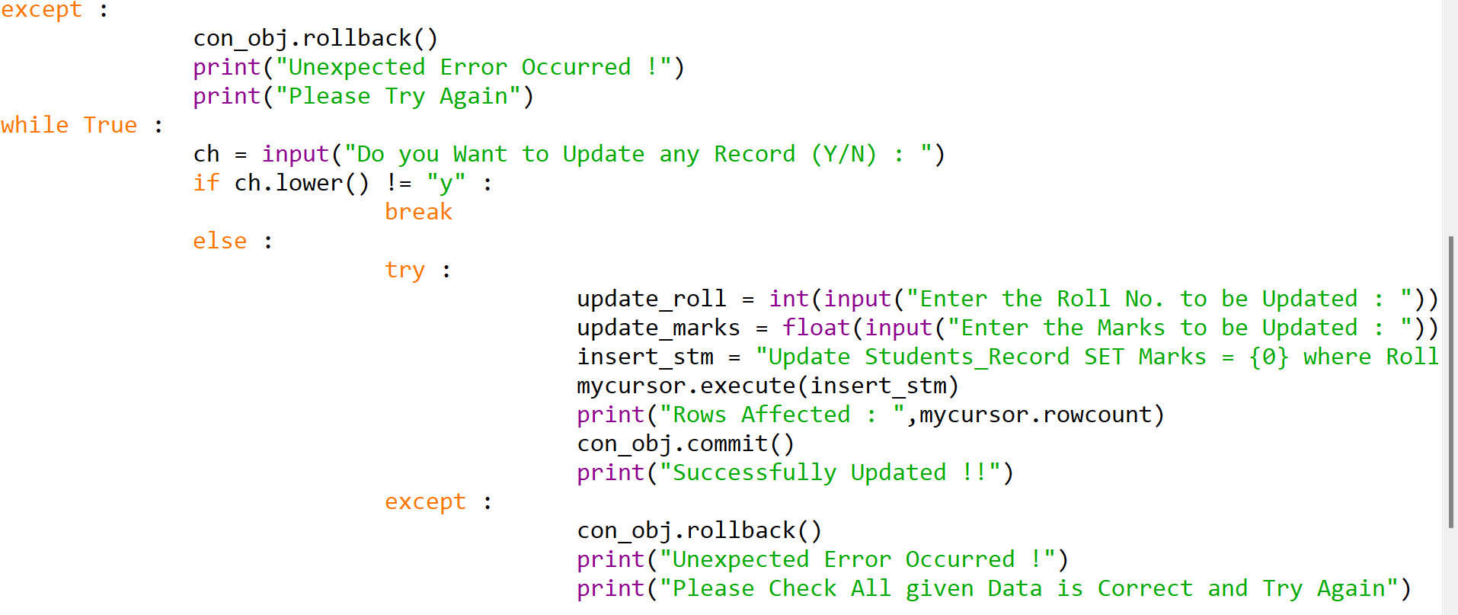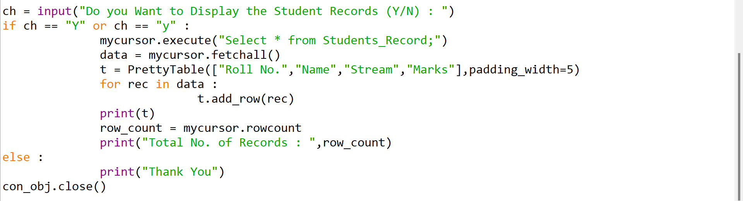

**Input/Output**

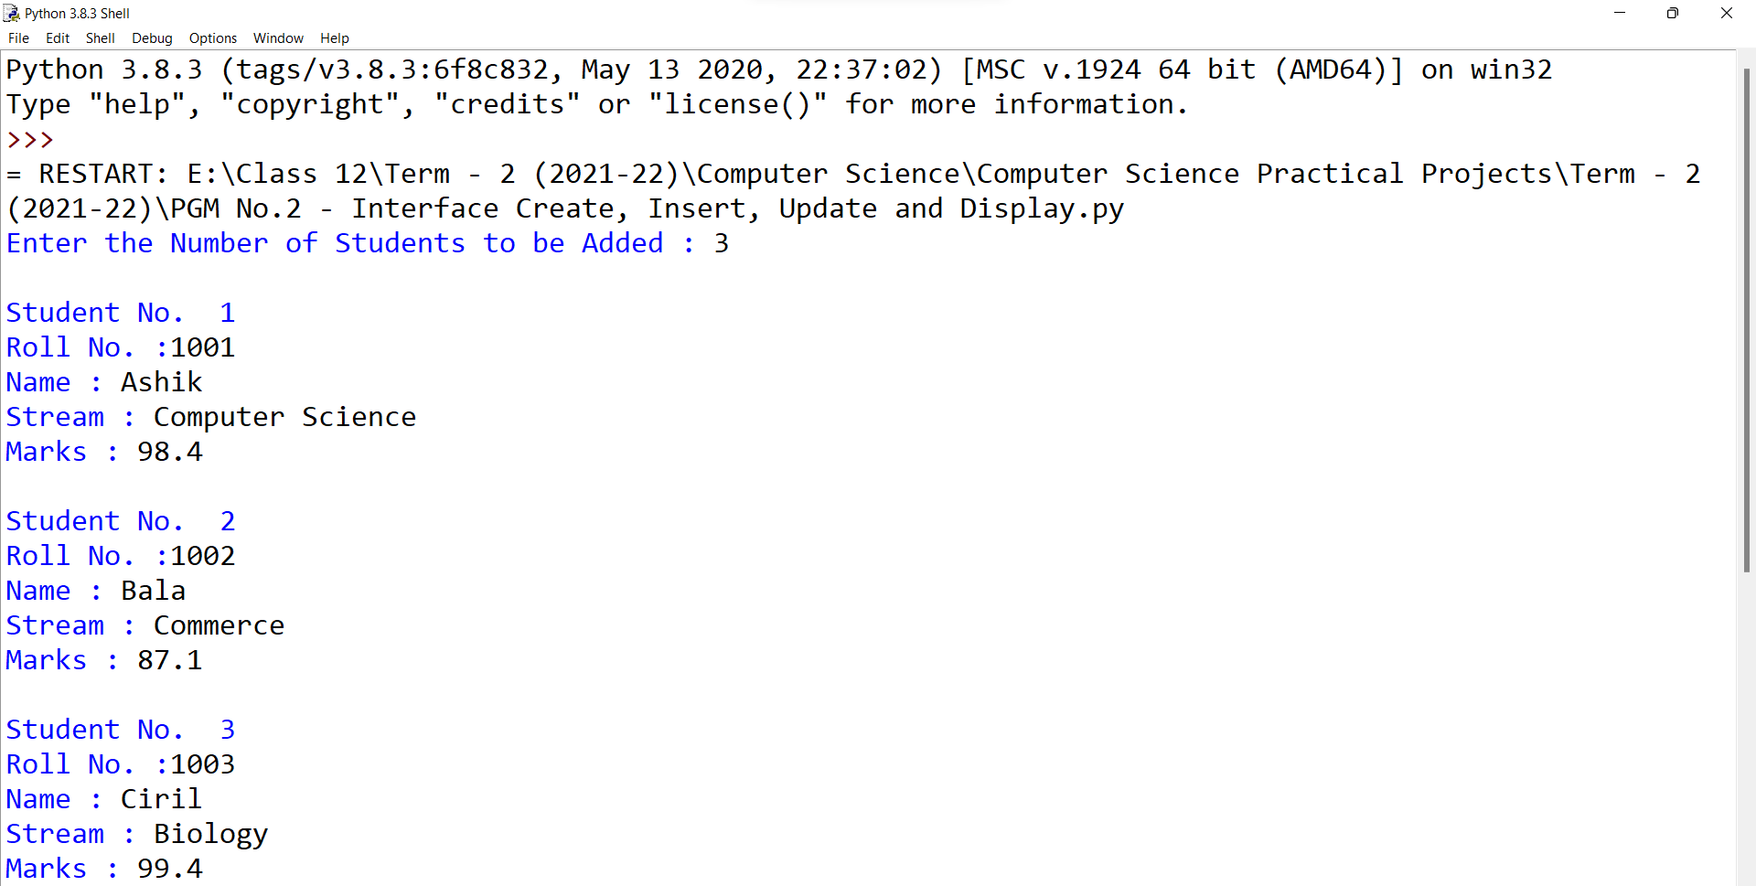

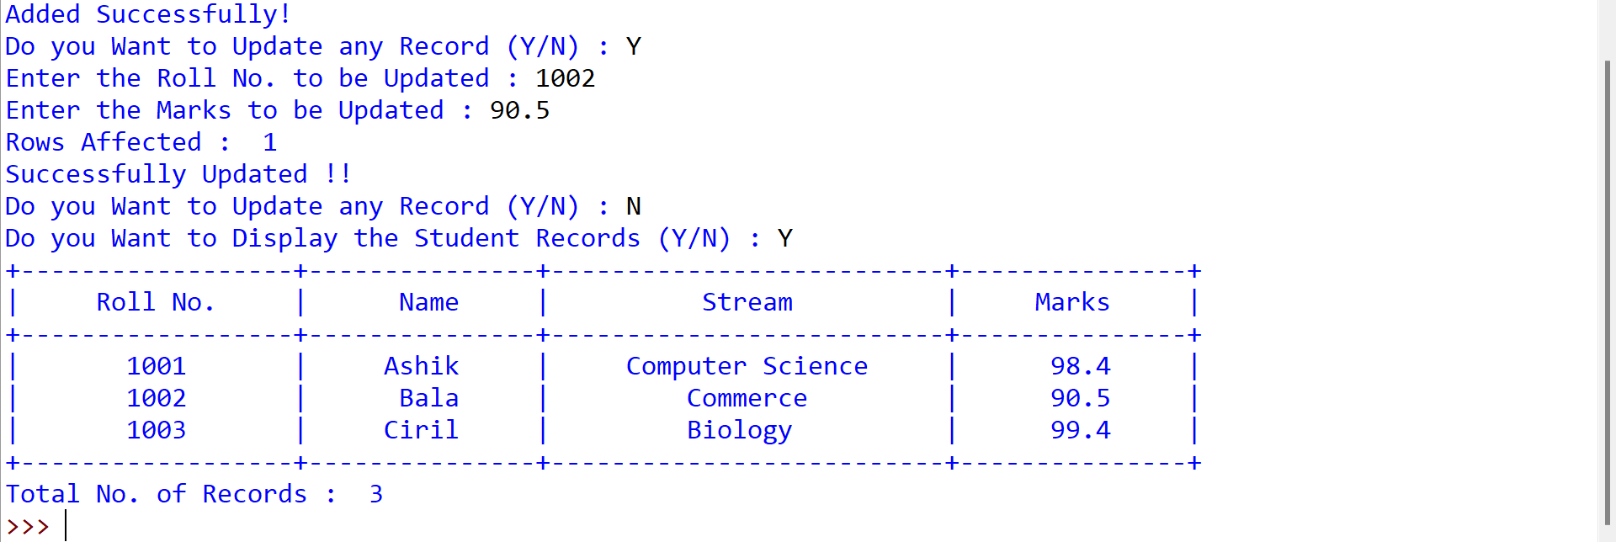

1. Write a python program Create, Insert, Delete and Display (Fetchall method) Students Record using Interfacing Concepts.

**Source Code:**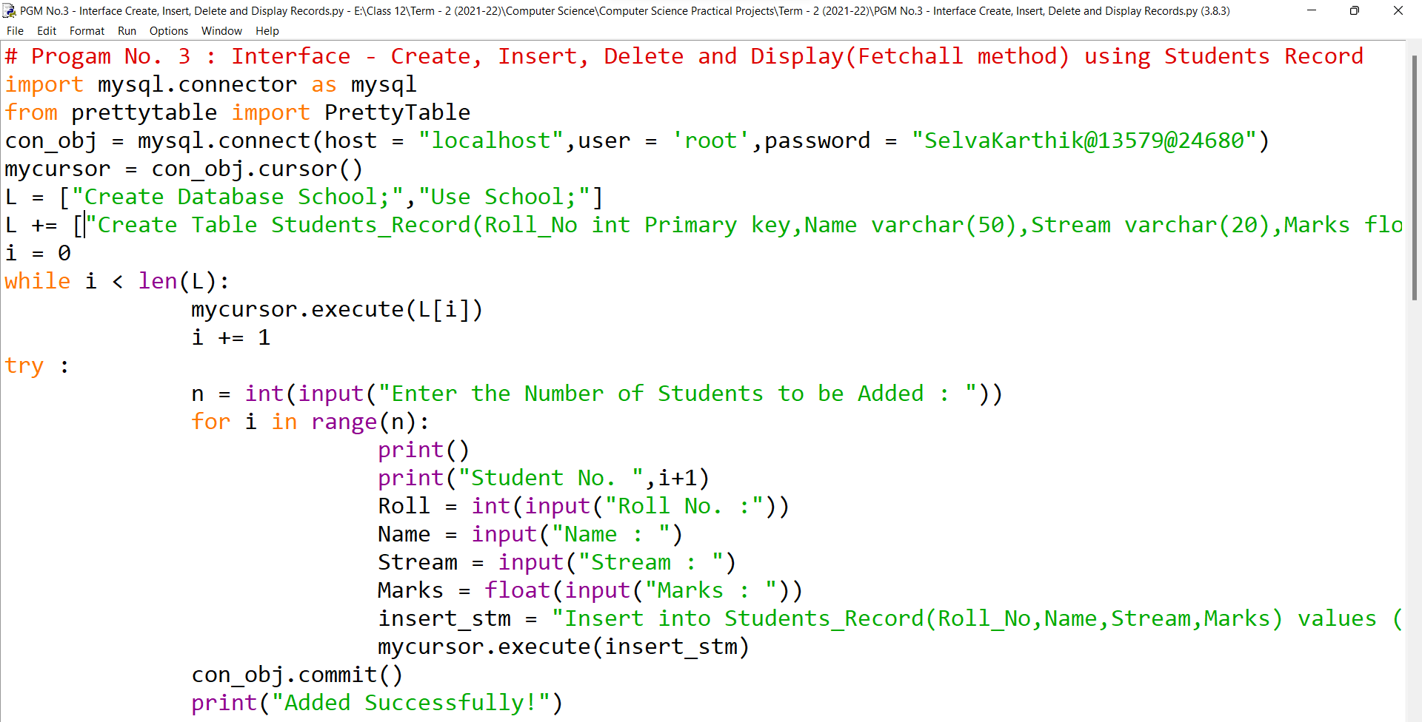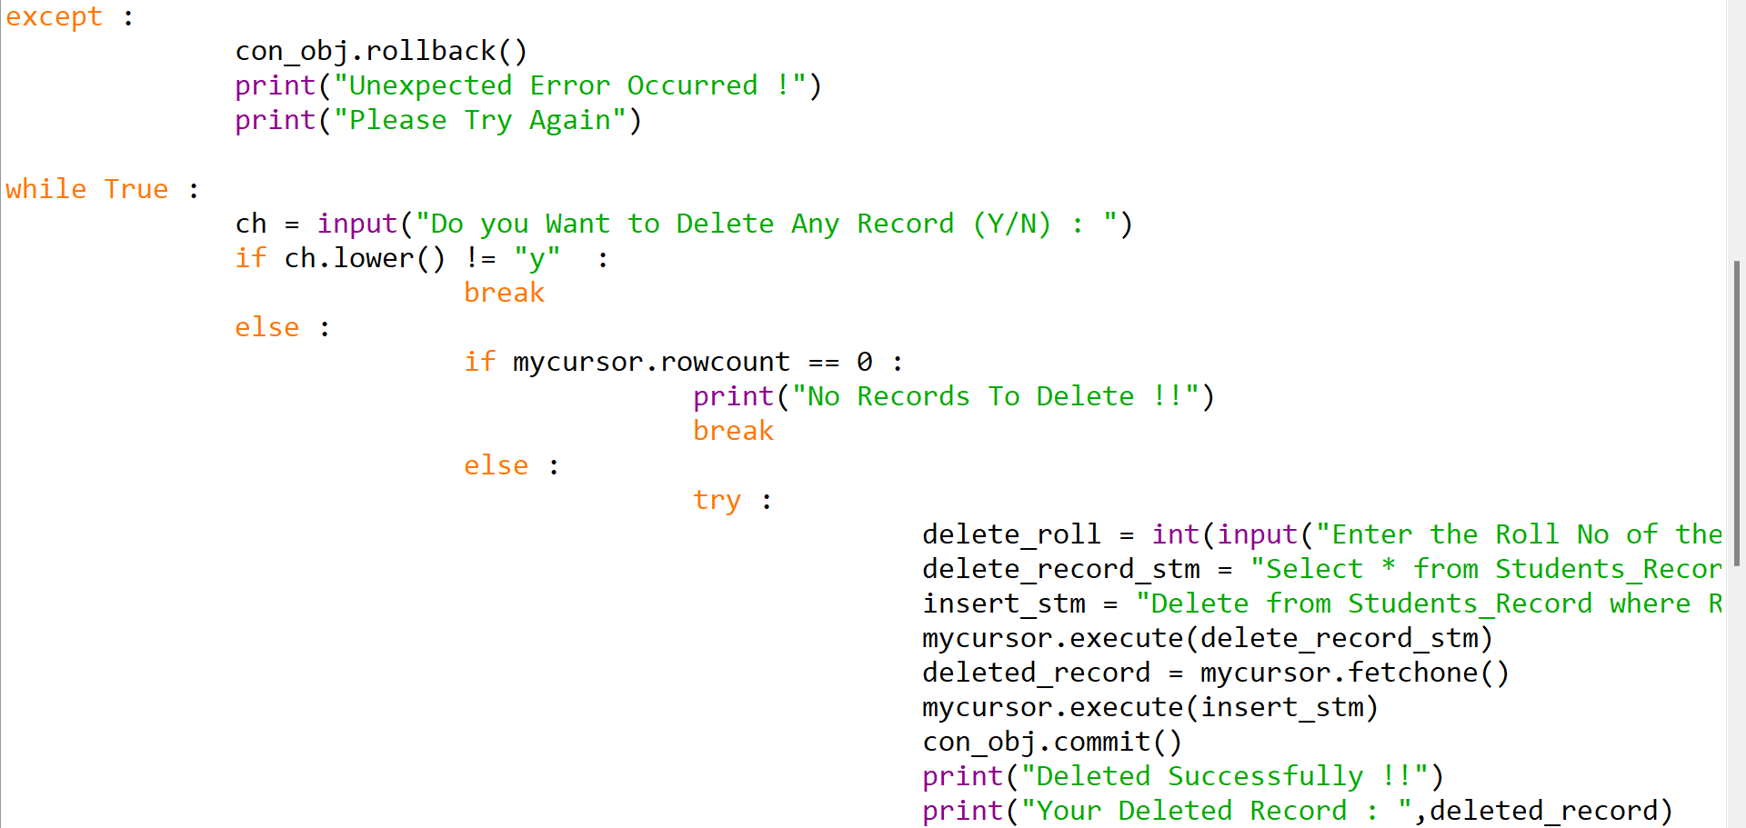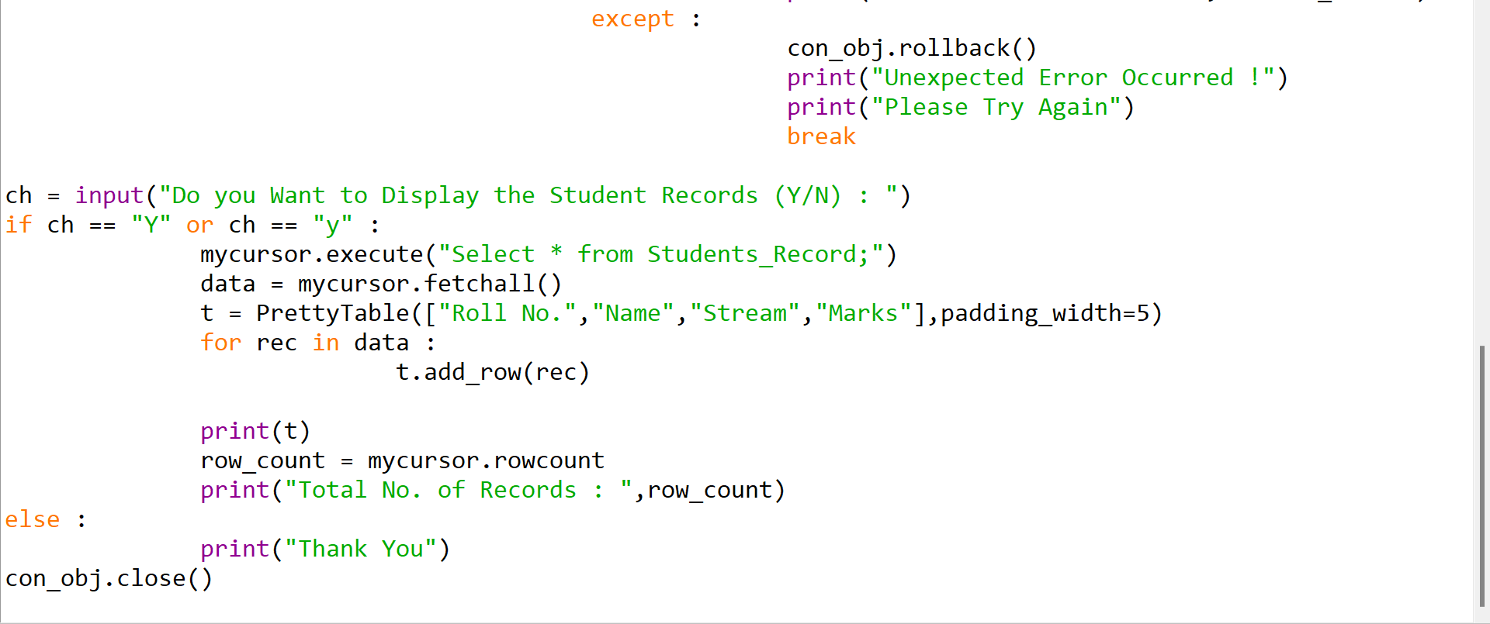

**Input/Output:**

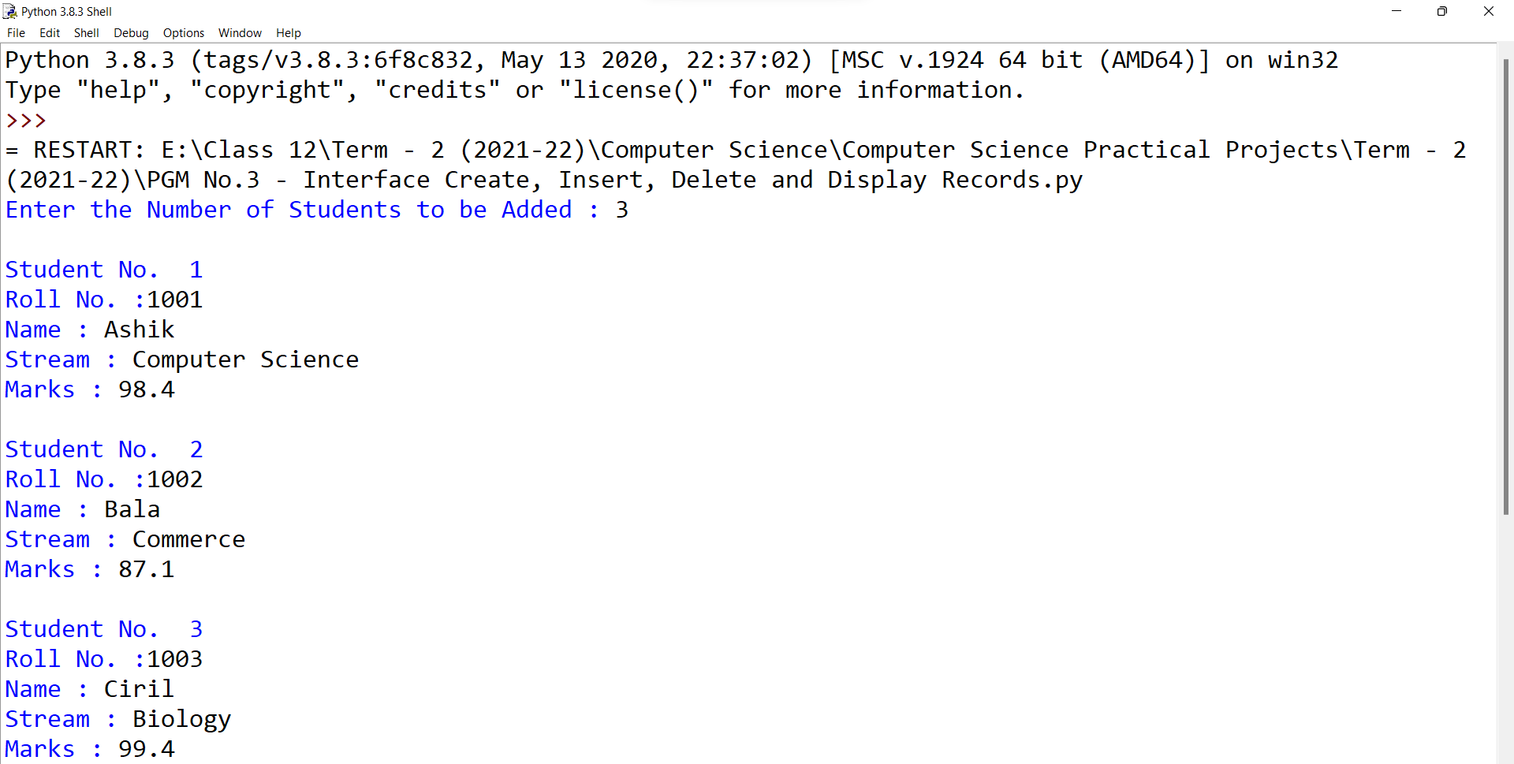

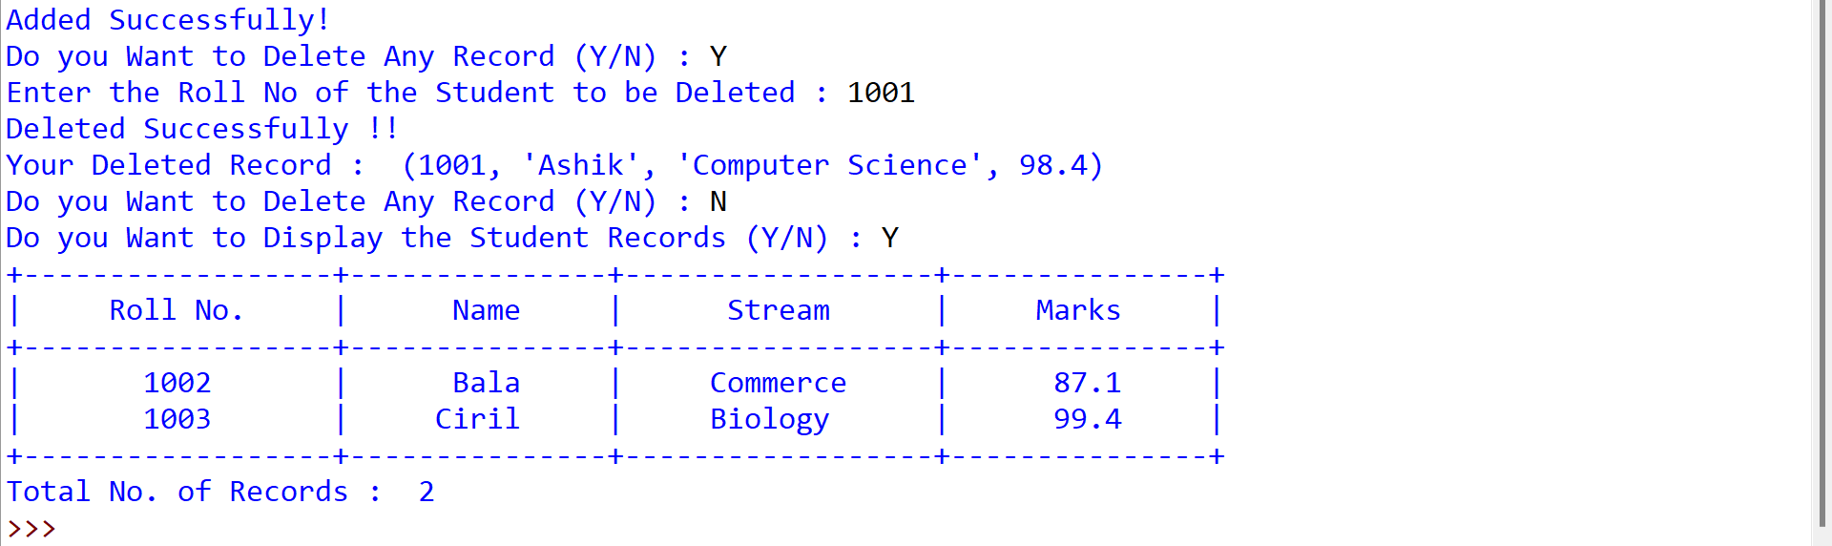

1. Write a program To Create, Insert, Display(Fetchall, Fetchmany, Fetchone) Students Record using Interfacing Concepts.

**Source Code:**

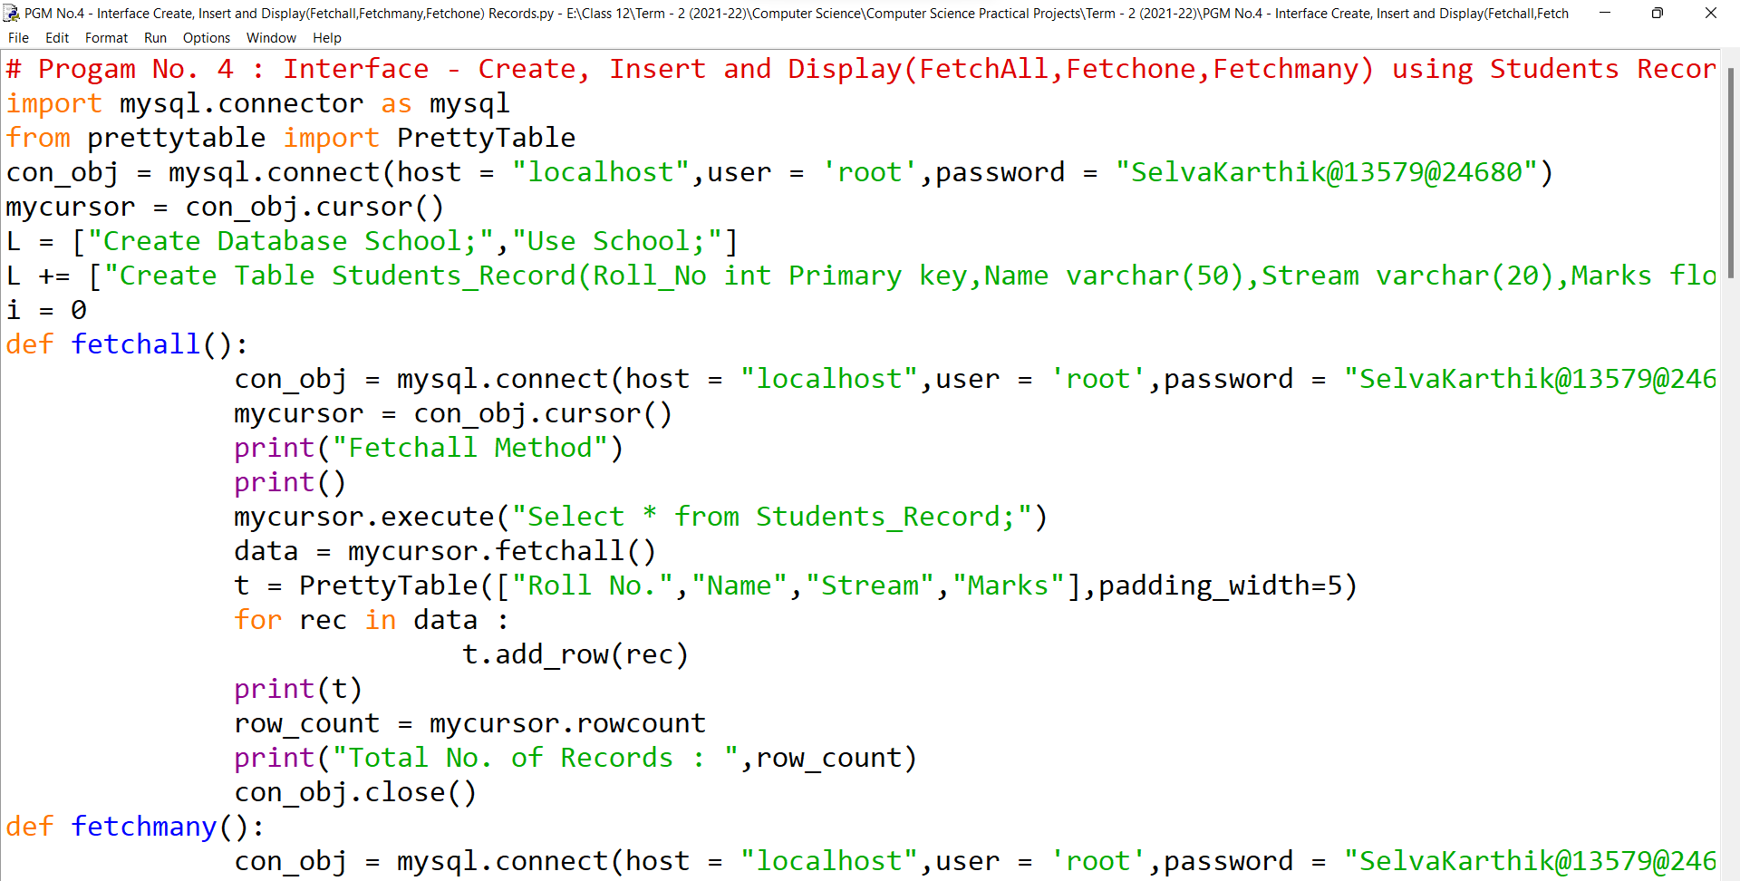

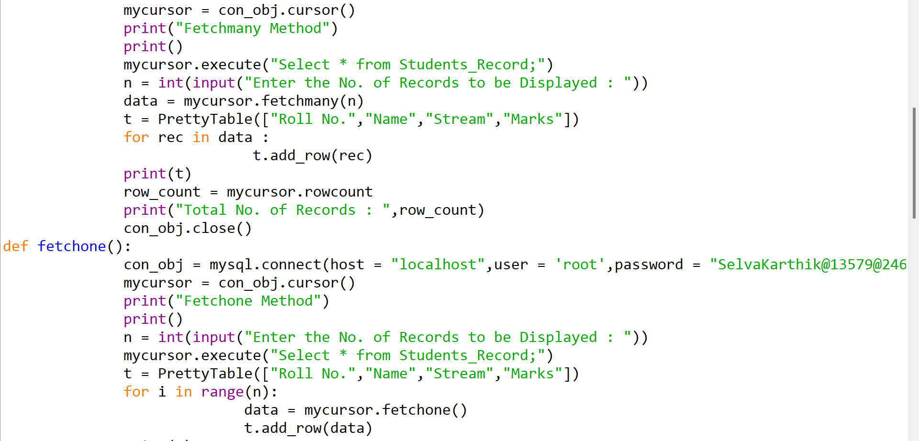

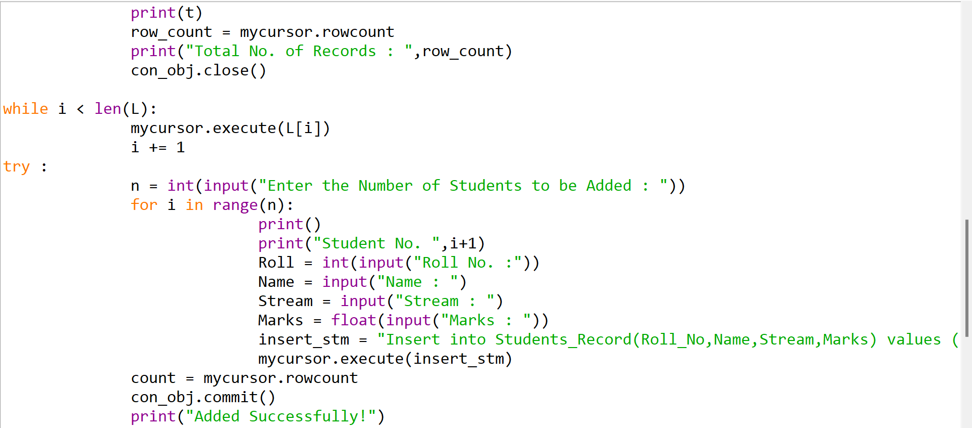 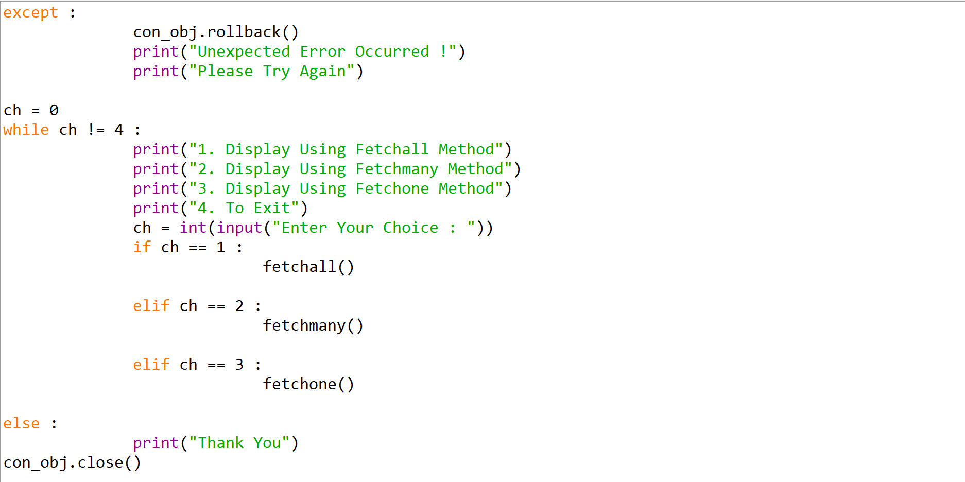

**Input/Output:**

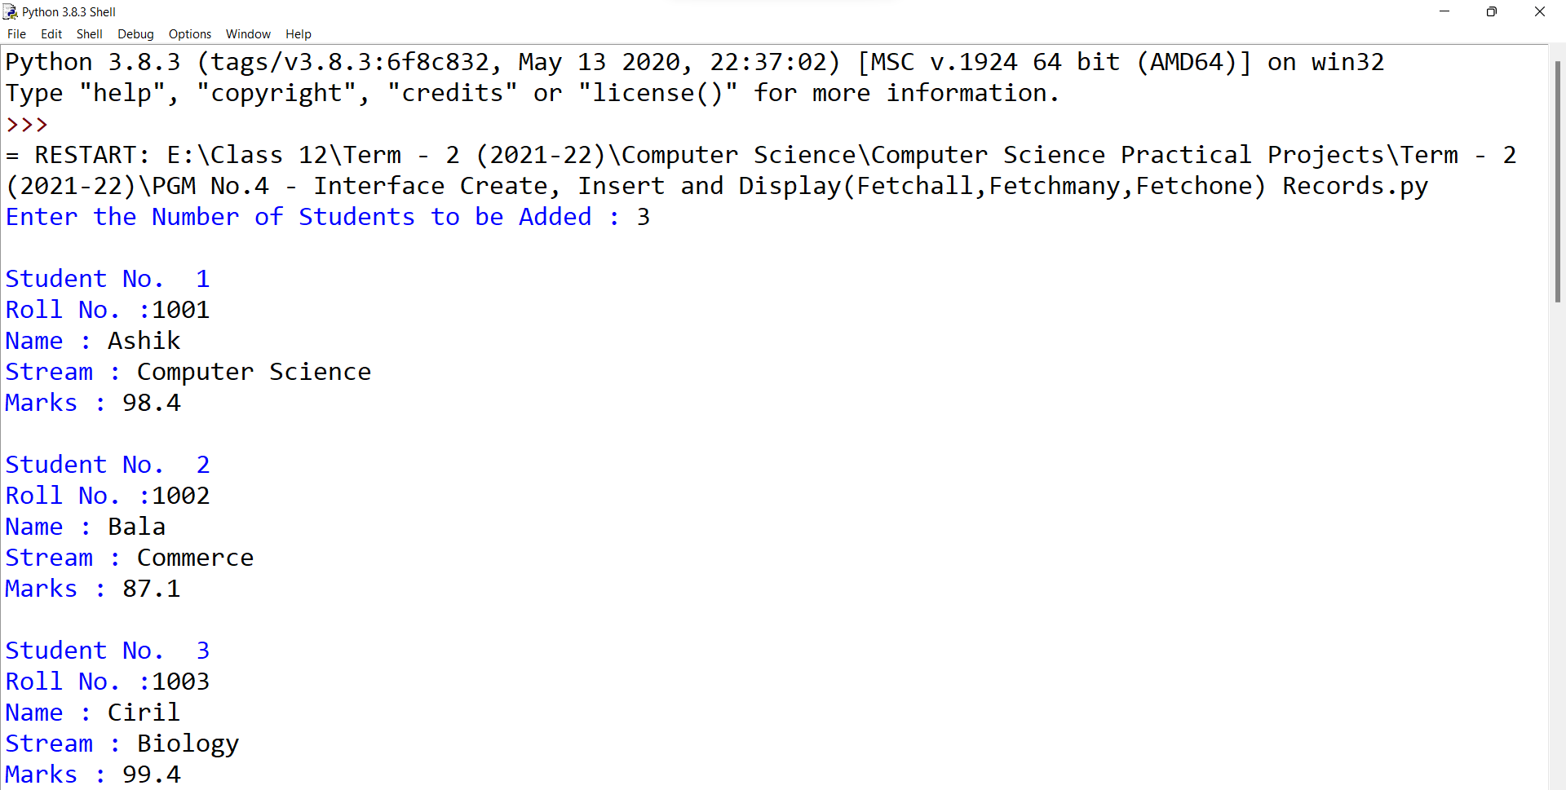

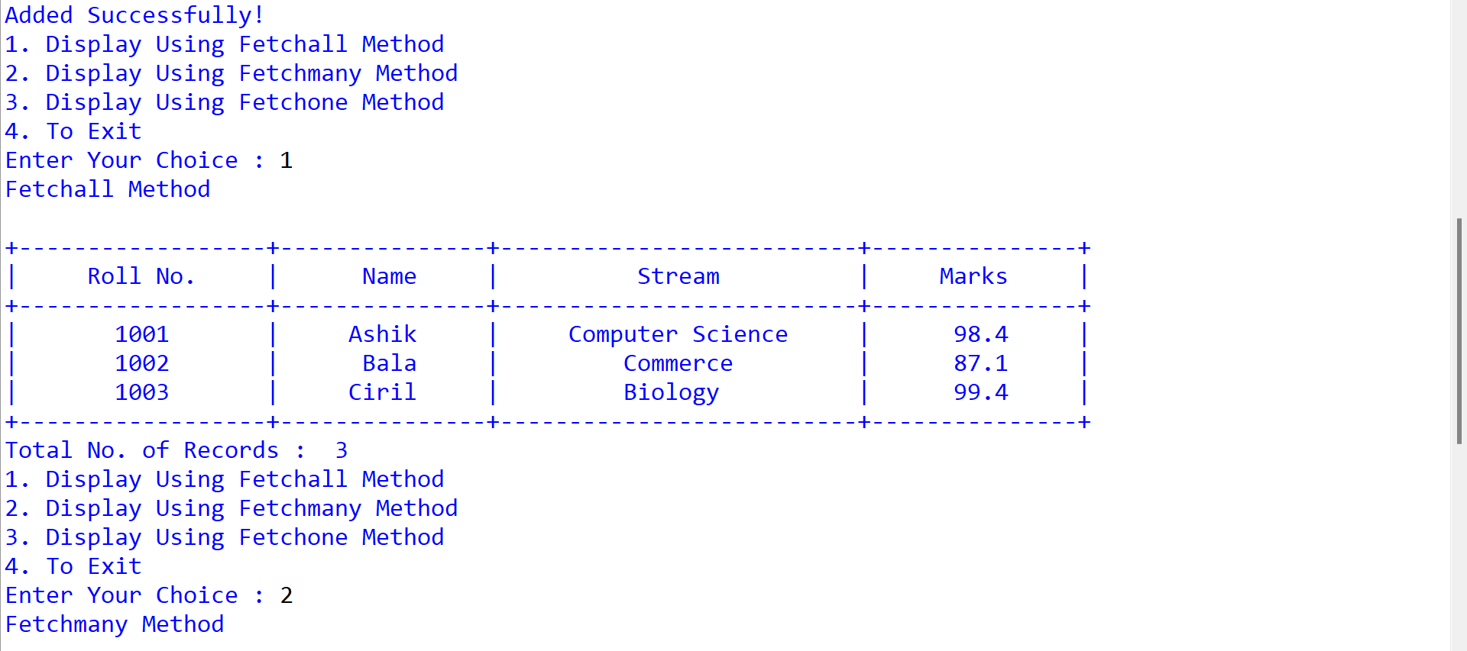

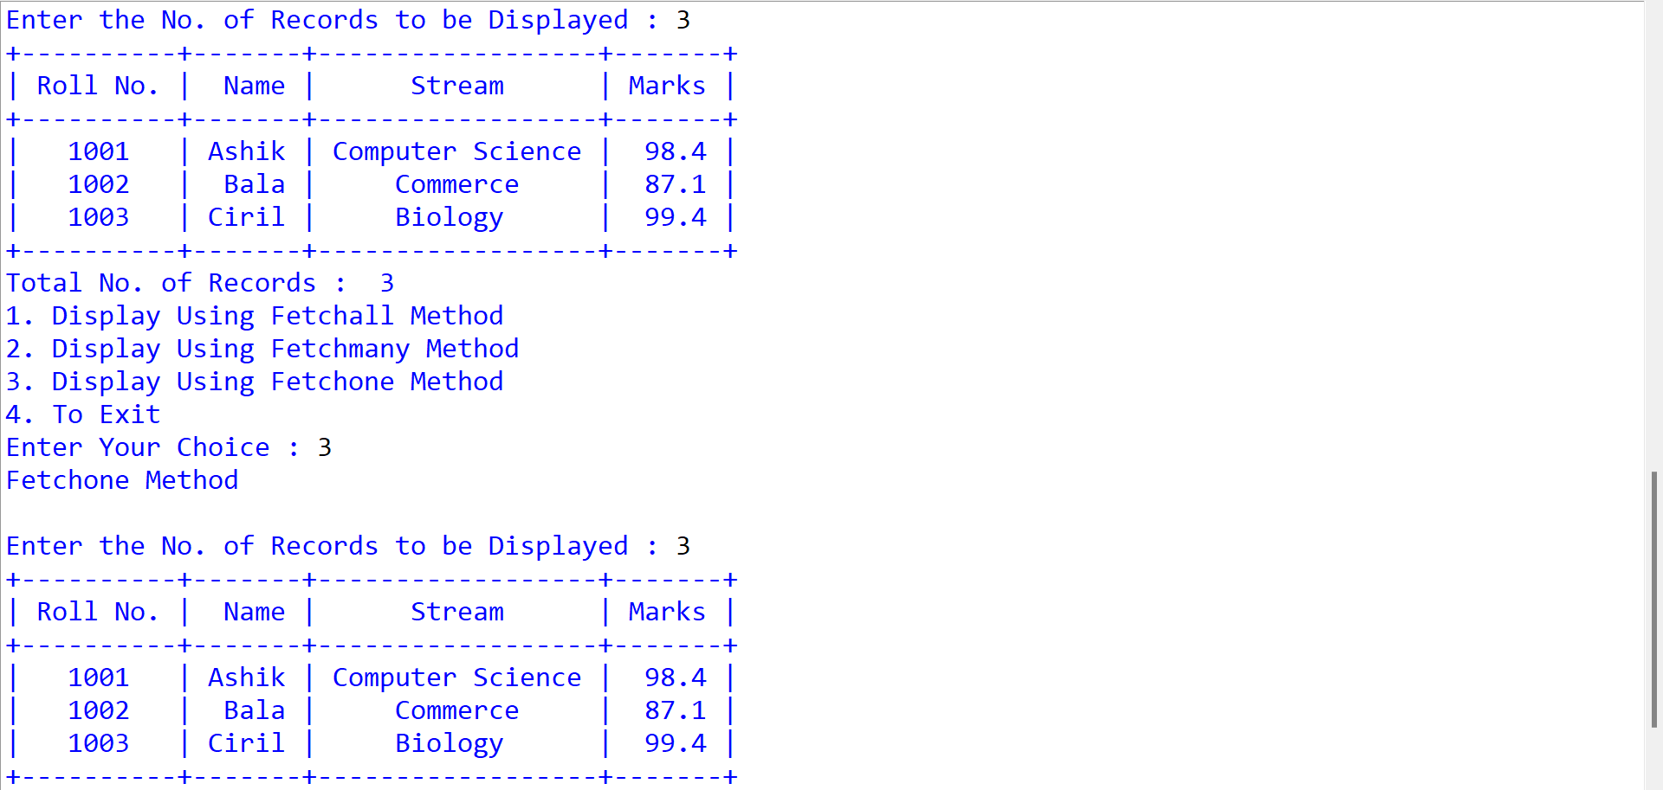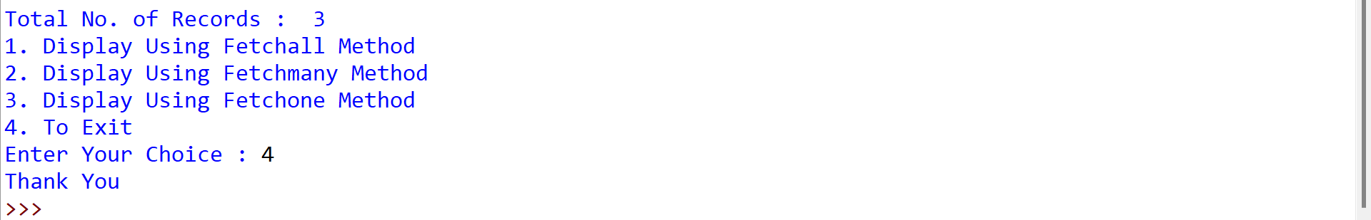

1. Write a program to Push, Pop and Display using Stack Operations.

**Source Code:** 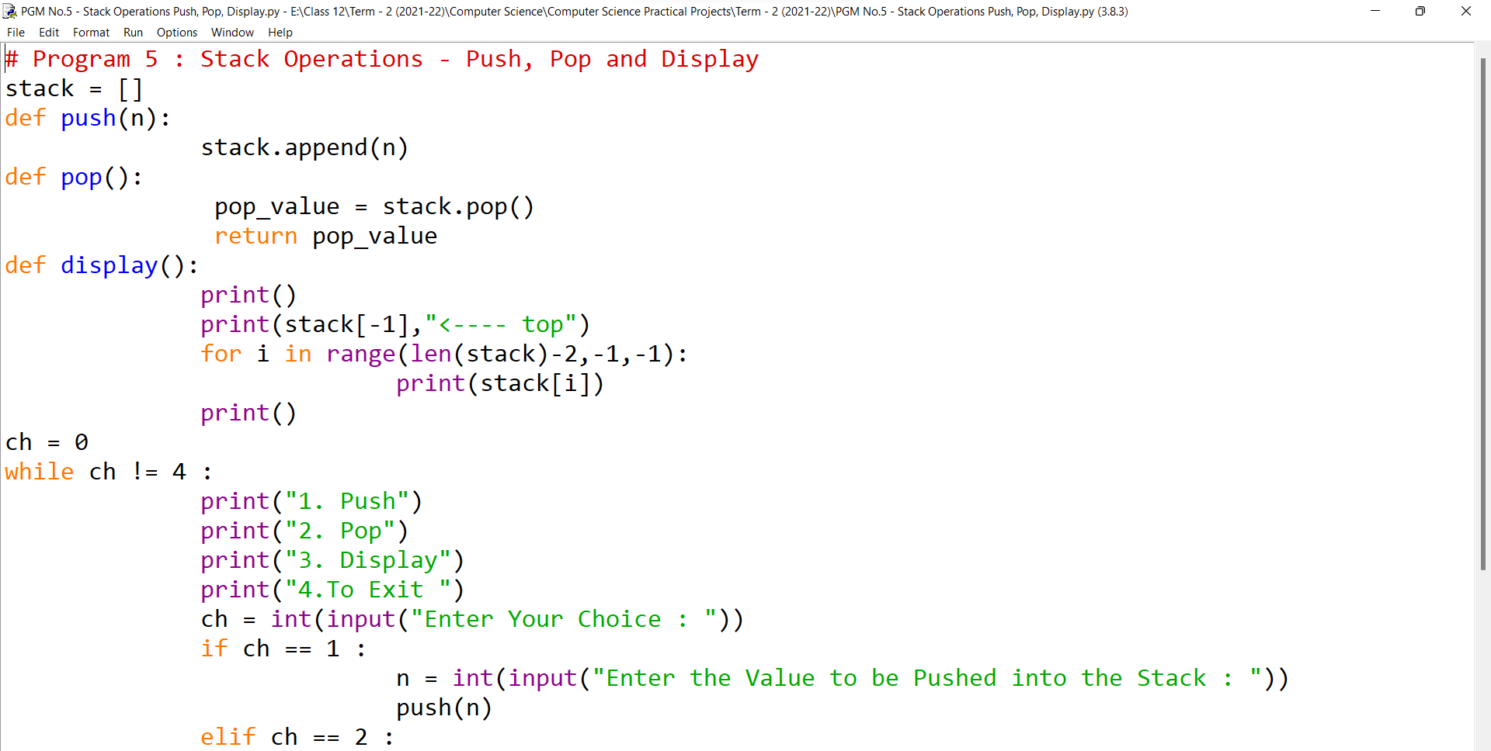 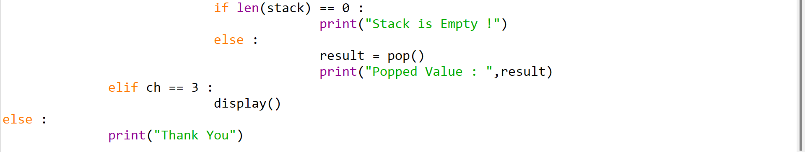

**Input/Output:**

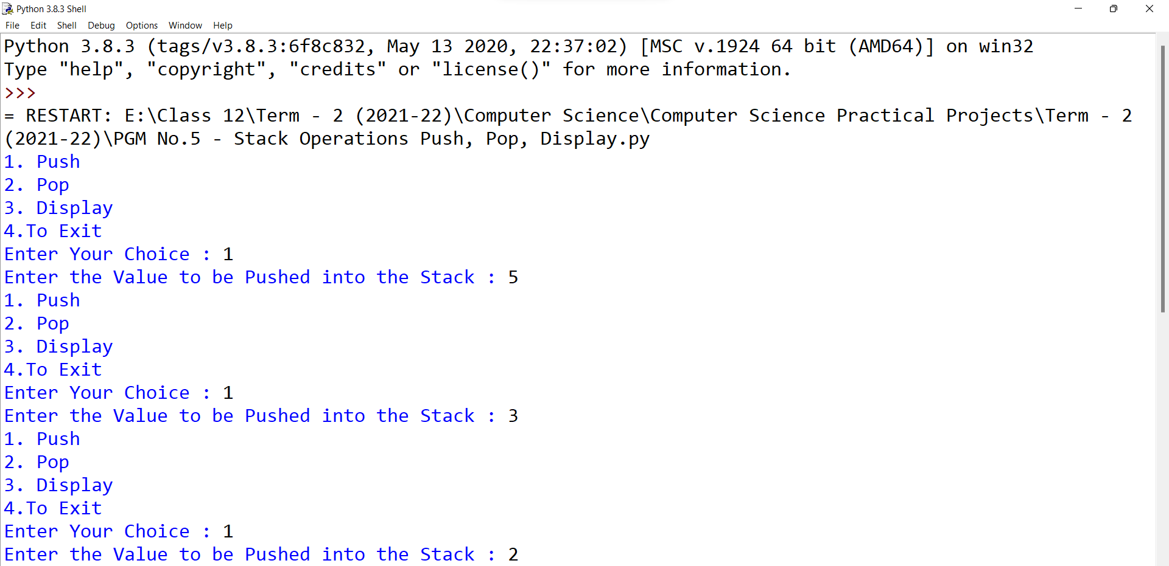

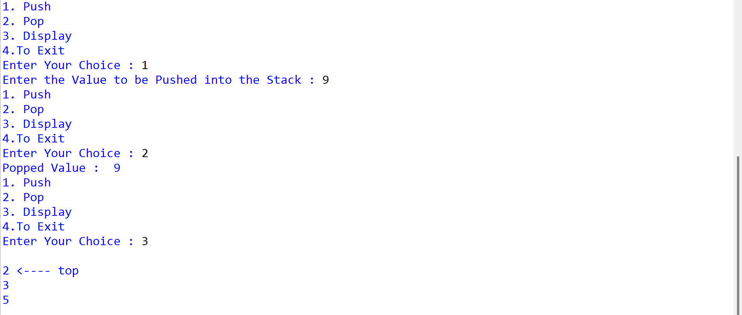 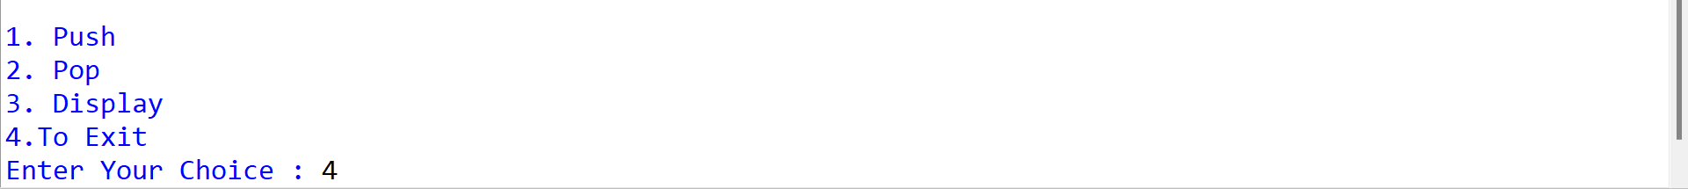

1. Write a program to Push, Pop and Display Book Details using Stack Operations.

**Source Code:**

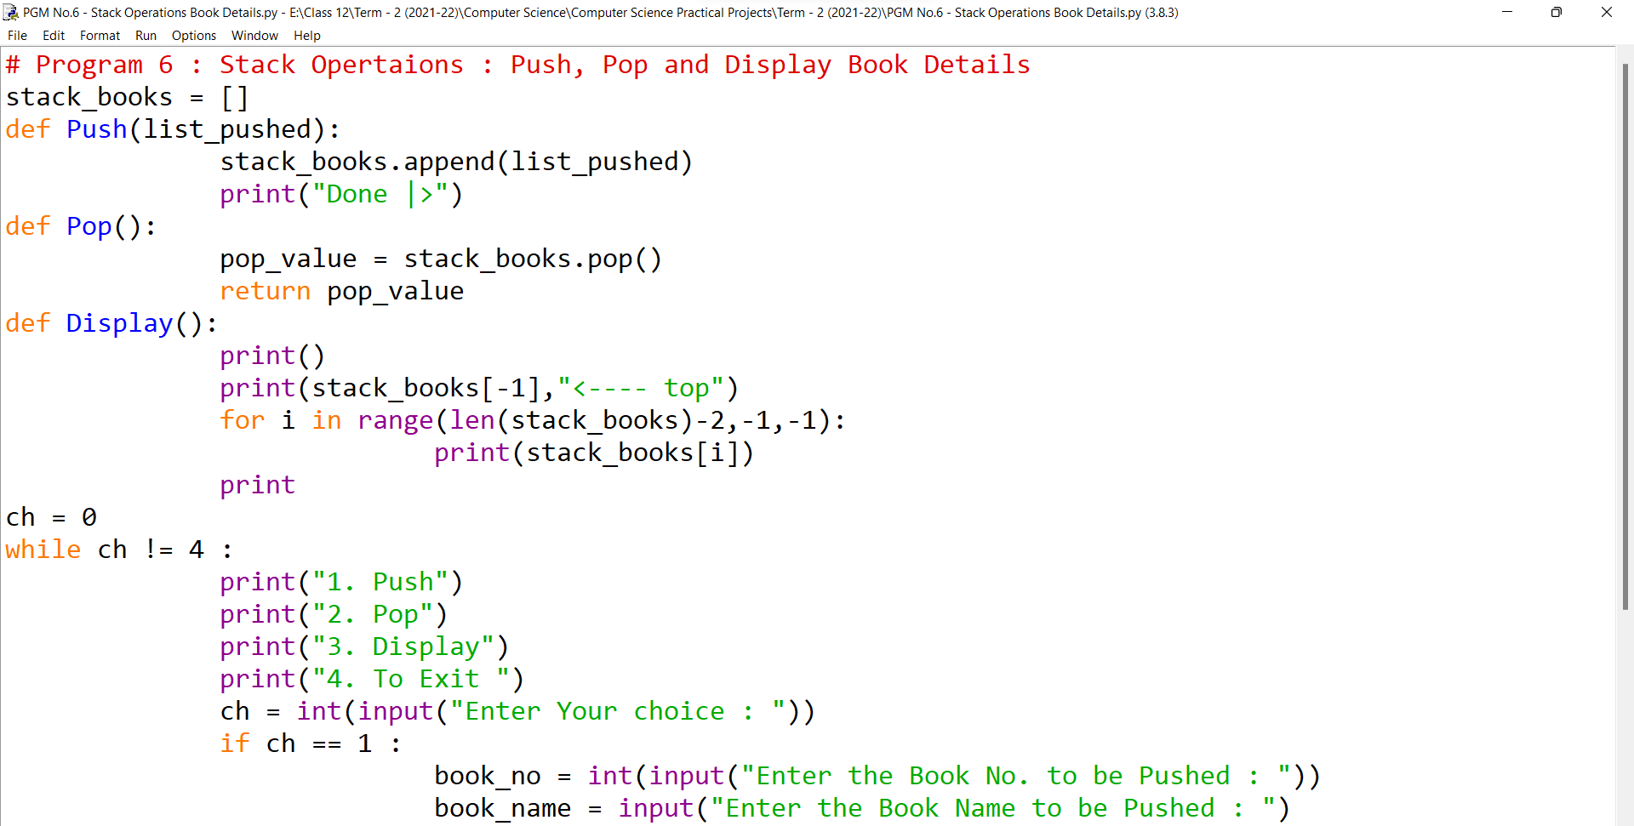 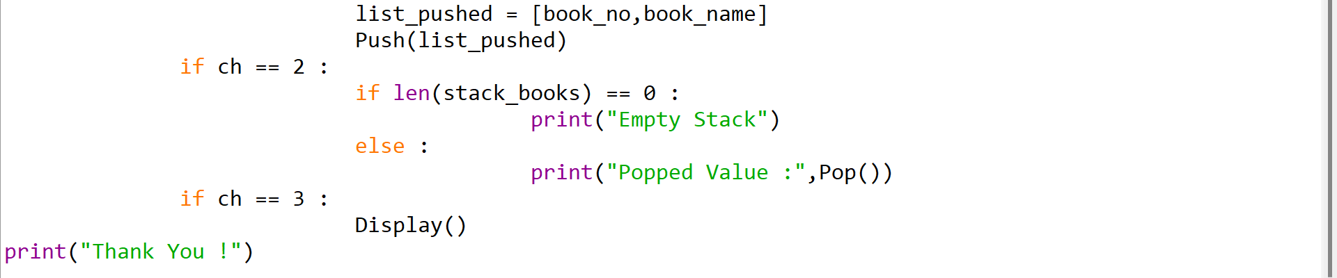

**Input/Output :**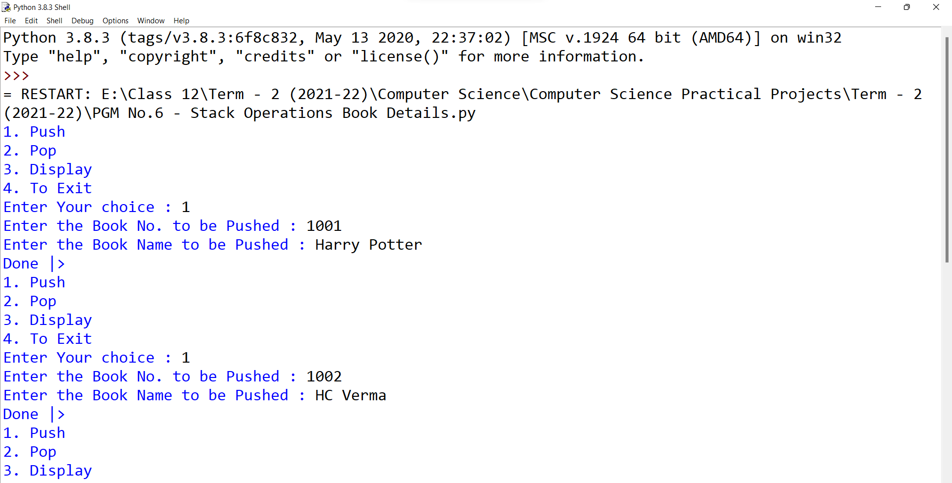 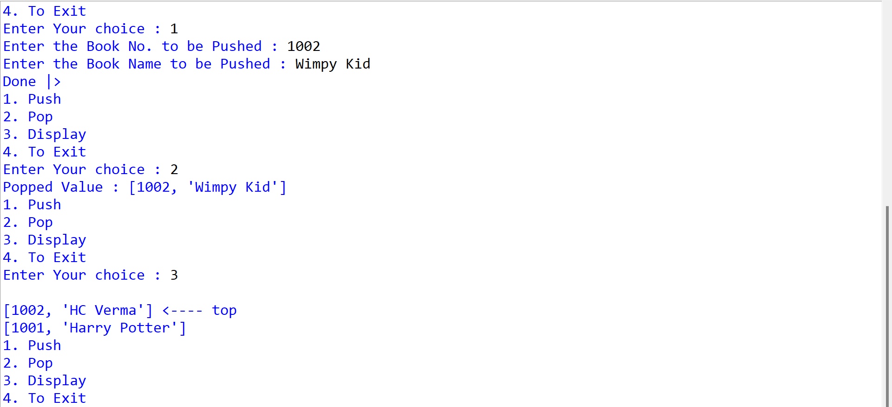 

1. Write a program to Push only Numbers which is Divisible by 5, Pop and Display using Stack Operations.

**Source Code:**

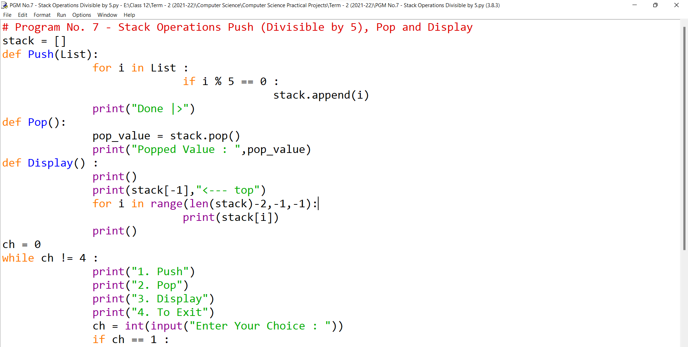 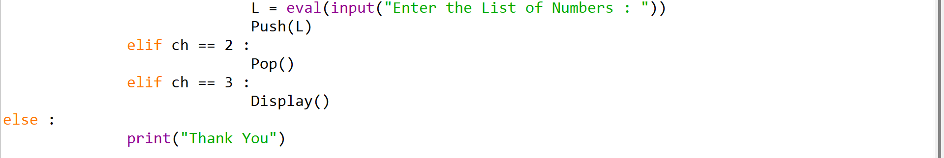

**Input/Output:**

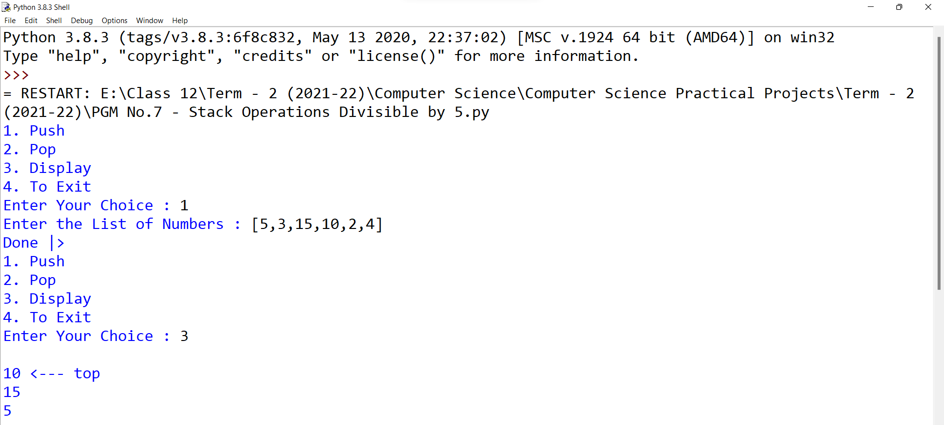 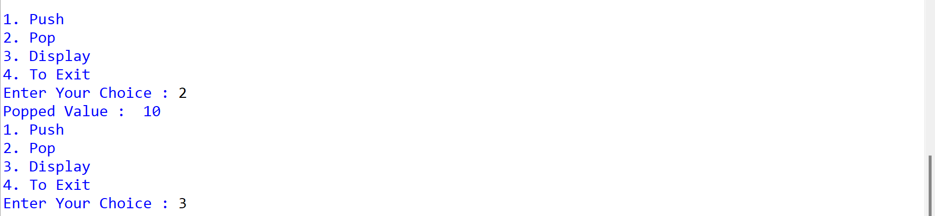

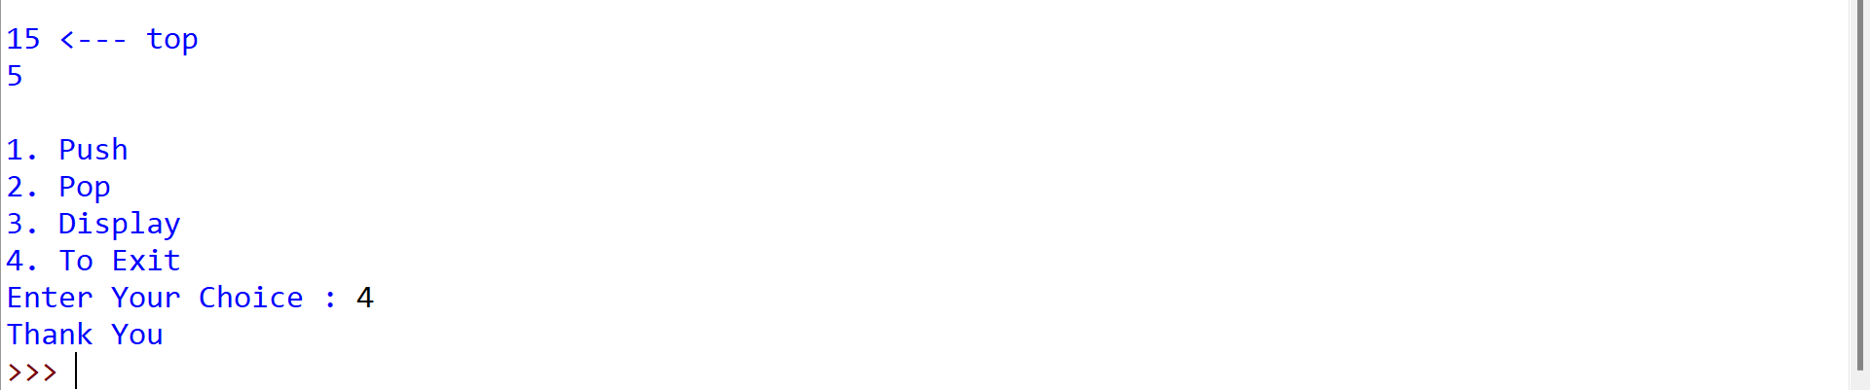

***SQL Experiments with Codes and Outputs (5 Experiments):***

**SQL - EXPERIMENT-**1

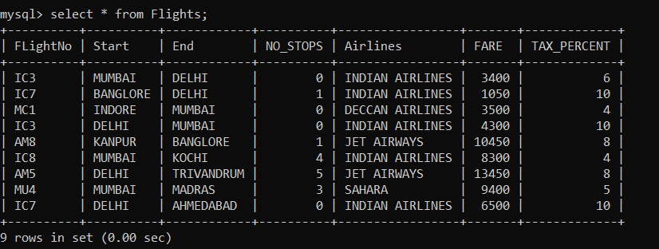

1. To display the AIRLINES wise average FARE and TAXP_PERCENT.

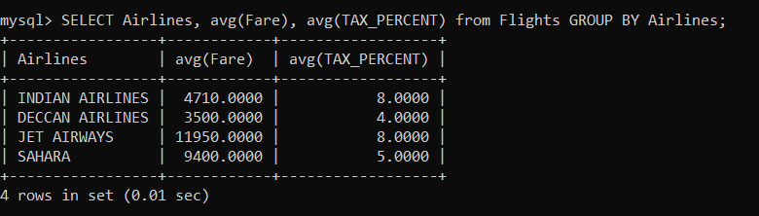

1. To display the FlightNo and Fare is the ascending order of TAX_PERCENT.

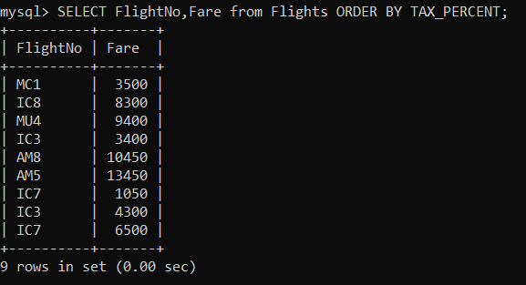

1. To display the Total Price of the flights from DELHI to MUMBAI, where the Total Price is calculated as: FARE+FARE*TAX_PERCENT/100.

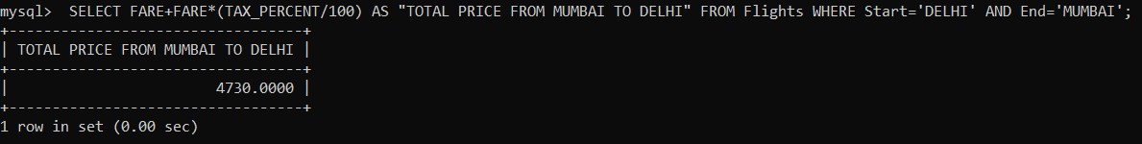

1. To display the minimum fare “Indian Airlines” is offering.

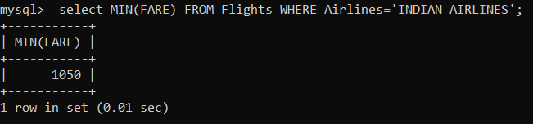

1. To display the AIRLINES in the ascending order of NO_STOPS and descending order of AIRLINES.

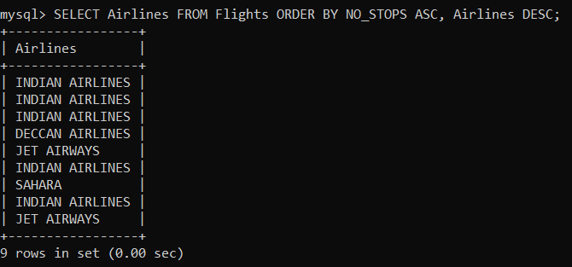

1. To display the total no. of flights from FLIGHTS where STARTING starts with a letter ‘M’ and the no. of stops is more than 2.

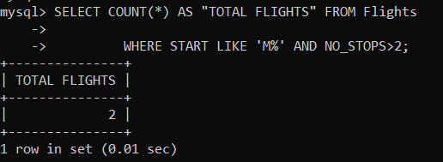

1. SELECT FL_NO, AIRLINES FROM FLIGHTS

       WHERE STARTING = ‘DELHI’;

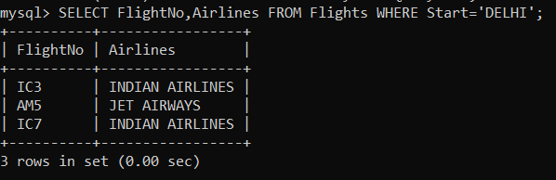

1. SELECT COUNT (DISTINCT ENDING) FROM FLIGHTS;

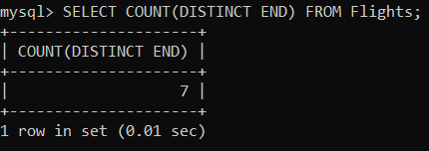

1. SELECT AIRLINES, SUM (FARE) FROM FLIGHTS

 GROUP BY AIRLINES HAVING SUM (FARE)> 10000

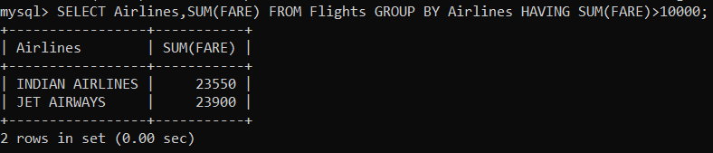

1. SELECT FL_NO, NO_STOPS, AIRLINES, FARE * TAXPERC/100 AS TAX FROM FLIGHTS WHERE NO_ STOPS BETWEEN 1 AND 3;

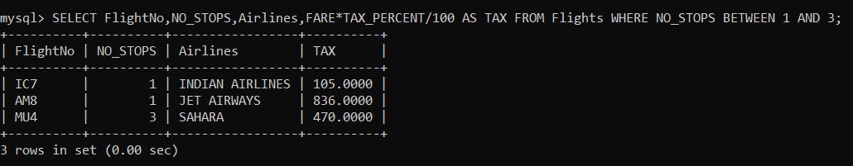

**SQL - EXPERIMENT-2**

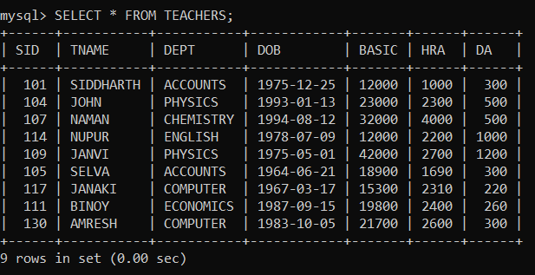

1. To display the names of the staff who are in Accounts department.

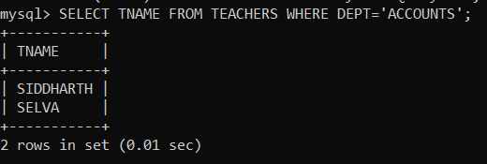

1. To display the Total Pay and Average Pay of all Employees. The salary for one person is calculated as: BASIC+HRA+DA

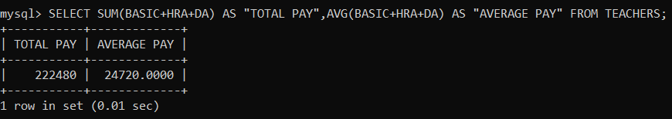

1. To display the names and dept of all staff who doesn’t have ‘a’ in their name.

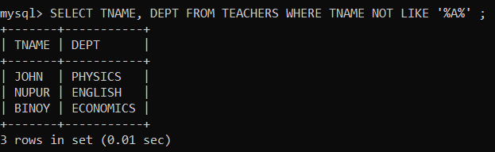

1. To display the SID and Department of the teachers in accordance to the seniority based on DOB.

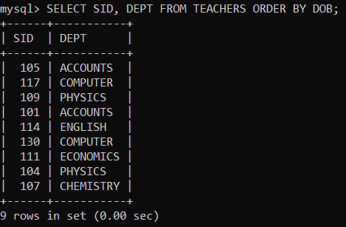

1. To display the report containing SID, Salary (BASIC + HRA + DA) and PF (BASIC*0.12).

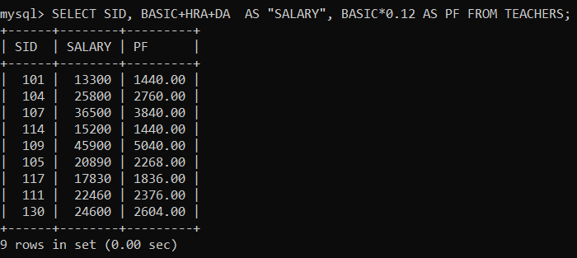

1. To display the details of the teachers who have their DOB in 1975.

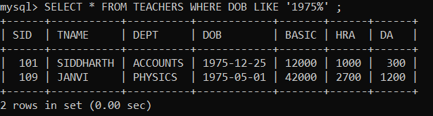

1. To display the no. of teachers in each department.

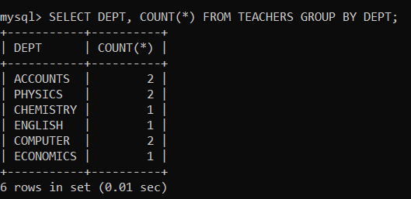

1. SELECT MAX(DOB), MIN(DOB) from Teacher;

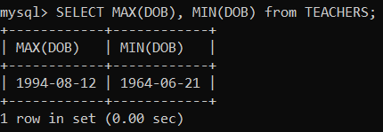

1. SELECT TNAME FROM TEACHER WHERE DEPT IN (‘ENGLISH’, ‘ECONOMICS, ACCOUNTS’) AND YEAR (DOB) BETWEEN 1965 AND 1990;

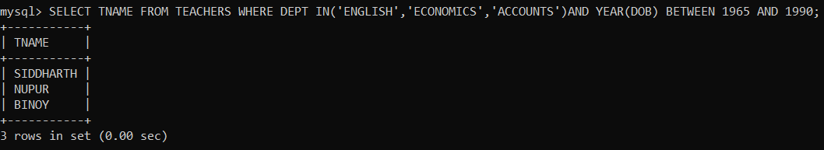

1. SELECT DISTINCT (DEPT) FROM TEACHER;

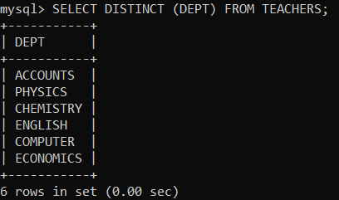

**SQL-3**

**Date:**

**AIM:** To create tables FACULTY and COURSES and execute the SQL commands.

**QUERY:**

**Create tables FACULTY and COURSES, write and execute the SQL queries for the given questions and observe the outputs.**

**Table: FACULTY**

|  |  |  |  |  |
| --- | --- | --- | --- | --- |
| **F_ID** | **Fname** | **Lname** | **Hire_date** | **Salary** |
| 102 | Amit | Mishra | 12/10/98 | 12000 |
| 103 | Nitin | Vyas | 24/12/94 | 8000 |
| 104 | Rakshit | Soni | 18/05/96 | 14000 |
| 105 | Rashmi | Malhotra | 11/09/97 | 11000 |
| 106 | Sulekha | Srivastava | 05/06/99 | 10000 |

**Table: COURSES**

|  |  |  |  |
| --- | --- | --- | --- |
| **C_ID** | **F_ID** | **Cname** | **Fees** |
| C21 | 102 | Grid Computing | 40000 |
| C22 | 106 | System Design | 16000 |
| C23 | 104 | Computer Security | 8000 |
| C24 | 106 | Human Biology | 15000 |
| C25 | 102 | Computer Network | 20000 |
| C26 | 105 | Visual Basic | 6000 |

**PROCEDURE:**

1. Open mysql software.
2. Enter the password.

**3.** Enter the following commands in the mysql prompt, mysql >

**4.** Create Database

**5.** Create table FACULTY(F_ID integer, Fname char(25), Lname char(25), Hire_Date date, Salary integer.

**6.**  Insert into FACULTY values(102,'Amit','Mishra',12/10/98,12000);

(Repeat this command with different values to insert all the records in the table FACULTY)

**7.** Create table COURSES(C_ID char(5), F_ID integer, Cname char(25), Fees integer);

**8.** Insert into COURSES values('C21',102,'Grid Computing', 40000);

(Repeat this command with different values to insert all the records in the table COURSES

**SQL Commands:**

1. **To display details of those faculties whose salary is greater than 12000.**

1. **To display the details of courses whose fees is in the range of 15000 to 50000(both values are included) A picture containing text

   Description automatically generated**
2. **To increase the fees of all courses by 500 of the course whose Cnmae starts with** **“Computer”.**

1. **To display details of those courses which are taught by 'Sulekha' in desending order of courses.**

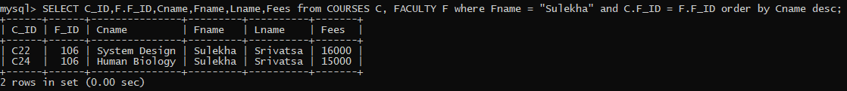

1. **To display the number of make F_ID in the COURSES table.**

1. **To display the name of the faculty who gets maximum salary.**

1. **To display the faculty name with the name of the courses taught by them.**

**RESULT:**

The SQL commands for the given queries are executed successfully and the outputs are observed.

**SQL-4**

**Date:**

**AIM:** To create DATABASE,TABLES and execute the SQL commands according to the following Query.

**QUERY:Create tables CABHUB and CUSTOMER , write and execute the SQL queries for the given questions and observe the outputs.**

**Table: CABHUB**

|  |  |  |  |  |  |
| --- | --- | --- | --- | --- | --- |
| **Vcode** | **Vehicle Name** | **Make** | **Color** | **Capacity** | **Charges** |
| 100 | Innova | Toyota | WHITE | 7 | 15 |
| 102 | SX4 | Suzuki | BLUE | 4 | 14 |
| 104 | C Class | Mercedes | RED | 4 | 35 |
| 105 | A-Star | Suzuki | WHITE | 3 | 14 |
| 108 | Indigo | Tata | SILVER | 3 | 12 |

**Table: CUSTOMER**

|  |  |  |
| --- | --- | --- |
| **Ccode** | **CName** | **Vcode** |
| 1 | Hemant sahu | 101 |
| 2 | Raj lal | 108 |
| 3 | Feroza Shah | 105 |
| 4 | Ketan Dhal | 104 |

**PROCEDURE:**

**1.** Open mysql software.

**2.** Enter the password.

**3.** Enter the following commands in the mysql prompt, mysql >

**4.** Create Database

**5.** Create table CABHUB(Vcode integer, VehicleName char(20),Make char(10),Color char(10),Capacity integer,Charges integer);

**6.** Insert into CABHUB values(101,'Innova','Toyota','WHITE',7,15);

(Repeat this command with different values to insert all the records in the table CABHUB

**7.** Create table CUSTOMER(Ccode integer,Cname varchar(25),Vcode integer);

**8.** Insert into CUSTOMER values(1,'Hemant sahu',101);

(Repeat this command with different values to insert all the records in the table CUSTOMER)

**SQL Commands:**

1. **To display all white coloured vehicles.**

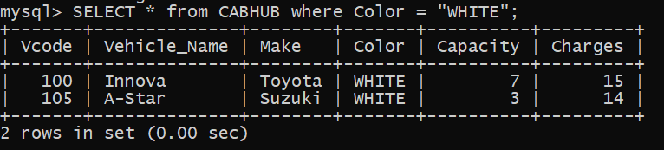

1. **To display the VehicleName , Make and Capacity in ascending order of their seating capacity.**

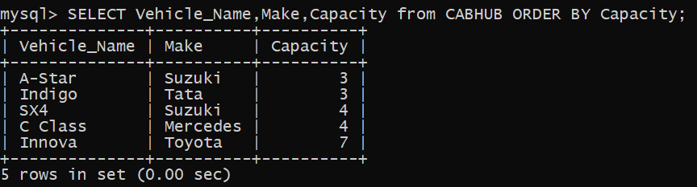

1. **To display the highest charges at which a vehicle can be hired from CABHUB.**

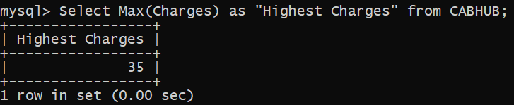

1. **To display the customer name and corresponding name of the vehicle hired by them.**

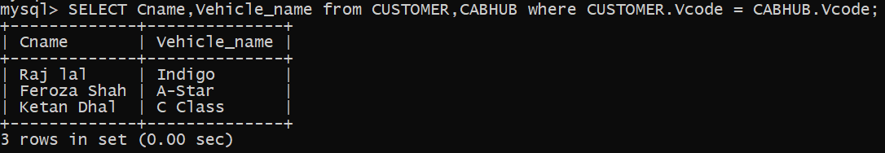

1. **To display the number of make vehicle in the table CABHUB.**

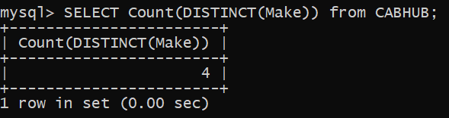

1. **To display the vehicle name, Name of the customer who has hired at the lowest charge.**



1. **To display the number of vehicles based on color from each other.**

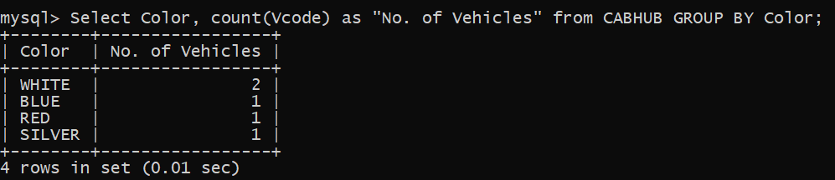

1. **To display the VehicleName whose capacity is 4.**

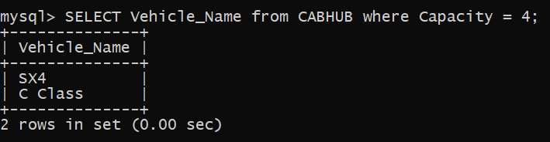

**RESULT:**

Thus, the SQL commands are executed successfully using MYSQL.

**SQL 5**

Write queries (a) to (d) based on the tables **EMPLOYEE** and **DEPARTMENT** given below:

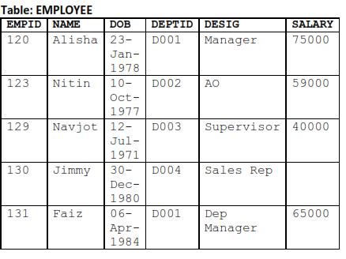

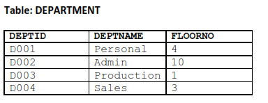

1. Create a Employee table with the attributes where the Empid is the primary key, and Department table with attributes where the DEPTID is the primary key.
2. Insert the details with the above tables.
3. To display the average salary of all employees, department wise.

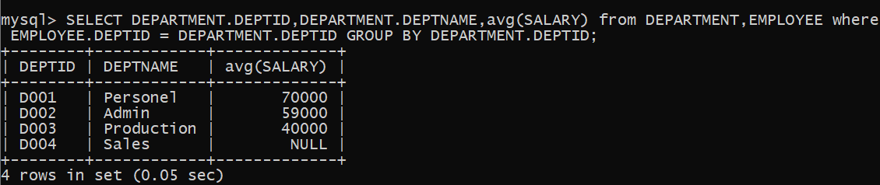

1. To display name and respective department name of each employee whose salary is more than 50000.

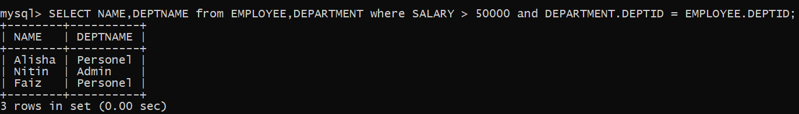

1. To display the names of employees whose salary is not known, in alphabetical order.

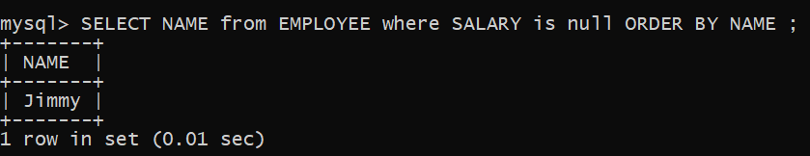

1. To display DEPTID from the table **EMPLOYEE** without repetition.

